5.3 (15pts):

The yield of a chemical process is being studied. The two most important variables are thought to be the pressure and the temperature. Three levels of each factor are selected, and a factorial experiment with two replicates is performed. The yield data are as follows.

Table : Factorial experiment data

|  |  |  |  |
| --- | --- | --- | --- |
|  | Pressure | Temperature | Yield |
| 1 | 200 | 150 | 90.4 |
| 2 | 200 | 150 | 90.2 |
| 3 | 215 | 150 | 90.7 |
| 4 | 215 | 150 | 90.6 |
| 5 | 230 | 150 | 90.2 |
| 6 | 230 | 150 | 90.4 |
| 7 | 200 | 160 | 90.1 |
| 8 | 200 | 160 | 90.3 |
| 9 | 215 | 160 | 90.5 |
| 10 | 215 | 160 | 90.6 |
| 11 | 230 | 160 | 89.9 |
| 12 | 230 | 160 | 90.1 |
| 13 | 200 | 170 | 90.5 |
| 14 | 200 | 170 | 90.7 |
| 15 | 215 | 170 | 90.8 |
| 16 | 215 | 170 | 90.9 |
| 17 | 230 | 170 | 90.1 |
| 18 | 230 | 170 | 90.4 |

1. Analyze the data and draw conclusions. Use α = 0.05.

Initially, a full-factorial design was used and yielded the following results:

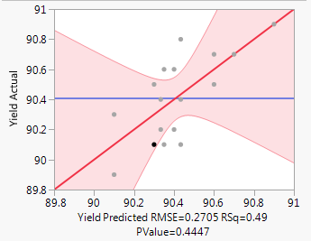

Figure : Actual by Predicted plot

Table :Effect summary

| **Source** | **LogWorth** |  | **PValue** |  |
| --- | --- | --- | --- | --- |
| Temperature | 0.980 |  | 0.10472 |  |
| Pressure*Temperature | 0.389 |  | 0.40825 |  |
| Pressure | 0.032 |  | 0.92819 | ^ |

As can be seen in Table 2, the interaction term is not significant. Therefore, the model was redefined so that only main effects were considered. After redefining the model in this way the following results were obtained:

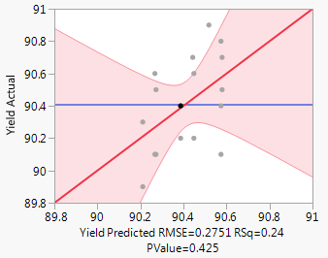

Figure : Actual by Predicted plot

Table :Effect summary

| **Source** | **LogWorth** |  | **PValue** |
| --- | --- | --- | --- |
| Temperature | 0.706 |  | 0.19678 |
| Pressure | 0.037 |  | 0.91892 |

The model generated is not significant (p = 0.425) and neither are any of the effects. I don’t think that any conclusions can be drawn from this model at this level of significance; which is to say that there is no evidence to suggest a relationship between the chemical process yield and the temperature, pressure, or the temperature pressure interaction term.

1. Prepare appropriate residual plots and comment on the model’s adequacy.

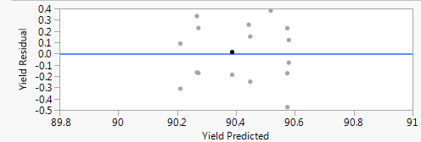

Figure :Residual plot

1. Under what conditions would you operate this process?

Because the model, and the main effects were not significant, I would run the process at whatever temperature and pressuer were most economical.

5.4 (10pts):

An engineer suspects that the surface finish of a metal part is influenced by the feed rate and the depth of cut. He selects three feed rates and four depths of cut. He then conducts a factorial experiment and obtains the following data:

Figure : Factorial experiment data for surface finish and factors

|  |  |  |  |
| --- | --- | --- | --- |
|  | Depth of Cut | Feed Rate | Surface Finish |
| 1 | 0.15 | 0.2 | 74 |
| 2 | 0.15 | 0.2 | 64 |
| 3 | 0.15 | 0.2 | 60 |
| 4 | 0.18 | 0.2 | 79 |
| 5 | 0.18 | 0.2 | 68 |
| 6 | 0.18 | 0.2 | 73 |
| 7 | 0.2 | 0.2 | 82 |
| 8 | 0.2 | 0.2 | 88 |
| 9 | 0.2 | 0.2 | 92 |
| 10 | 0.25 | 0.2 | 99 |
| 11 | 0.25 | 0.2 | 104 |
| 12 | 0.25 | 0.2 | 96 |
| 13 | 0.15 | 0.25 | 92 |
| 14 | 0.15 | 0.25 | 86 |
| 15 | 0.15 | 0.25 | 88 |
| 16 | 0.18 | 0.25 | 98 |
| 17 | 0.18 | 0.25 | 104 |
| 18 | 0.18 | 0.25 | 88 |
| 19 | 0.2 | 0.25 | 99 |
| 20 | 0.2 | 0.25 | 108 |
| 21 | 0.2 | 0.25 | 95 |
| 22 | 0.25 | 0.25 | 104 |
| 23 | 0.25 | 0.25 | 110 |
| 24 | 0.25 | 0.25 | 99 |
| 25 | 0.15 | 0.3 | 99 |
| 26 | 0.15 | 0.3 | 98 |
| 27 | 0.15 | 0.3 | 102 |
| 28 | 0.18 | 0.3 | 104 |
| 29 | 0.18 | 0.3 | 99 |
| 30 | 0.18 | 0.3 | 95 |
| 31 | 0.2 | 0.3 | 108 |
| 32 | 0.2 | 0.3 | 110 |
| 33 | 0.2 | 0.3 | 99 |
| 34 | 0.25 | 0.3 | 114 |
| 35 | 0.25 | 0.3 | 107 |
| 36 | 0.25 | 0.3 | 111 |

1. Analyze the data and draw conclusions. Use α = 0.05.

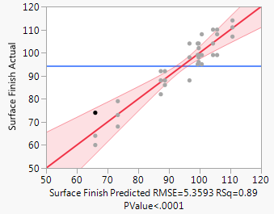

Figure :Actual by Predicted plot

The figure above shows the actual response vs. the response predicted by our model. We can conclude from this experiment design that the model is significant. Based on the effect summary table below, it can also be concluded that both main effects and the interaction term are significant in this model.

Table :Effect summary

| **Source** | **LogWorth** |  | **PValue** |
| --- | --- | --- | --- |
| Feed Rate | 8.964 |  | 0.00000 |
| Depth of Cut | 6.782 |  | 0.00000 |
| Depth of Cut*Feed Rate | 1.745 |  | 0.01797 |

Finally, we can conclude that there is a feed rate and depth of cut at which the process should be run in order to obtain the best surface finish results.

1. Prepare appropriate residual plots and comment on the model’s adequacy.

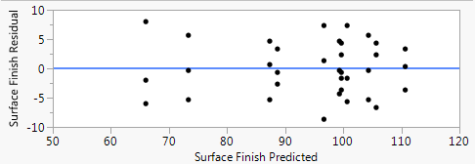

Table : Residual plot

The residual plot doesn’t show any cause for concern. There do not appear to be any patterns in the residuals.

1. Obtain point estimates of the mean surface finish at each feed rate.

Table :Point estimate surface finish for given feed rate

|  |  |
| --- | --- |
| Feed Rate (in/min) | Surface Finish |
| 0.20 | 66 |
| 0.25 | 88.67 |
| 0.3 | 99.67 |

1. Find the P-values for the tests in part A.

Refer to Table 4.

5.5 (5pts):

For the data in Problem 5.4, compute a 95 percent confidence interval estimate of the mean difference in response for feed rates of 0.20 and 0.25 in/min.

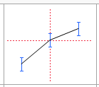

Figure : Prediction profiler output

I’m not sure how to get the mean difference data out of JMP. However, the 95% confidence interval as shown using JMP’s prediction profiler is as follows:

|  |  |
| --- | --- |
| Feed Rate (in/min) | Surface Finish |
| 0.20 | [59.61 – 72.86] |
| 0.25 | [82.28 – 95.05] |

5.21 (10pts):

The yield of a chemical process is being studied. The two factors of interest are temperature and pressure. Three levels of each factor are selected; however, only nine runs can be made in one day. The experimenter runs a complete replicate of the design on each day. The data are shown in the following table. Analyze the data, assuming that the days are blocks.

1. Analyze the data from this experiment (use α = 0.05).
2. Analyze the residuals.
3. Repeat the analyses from parts A and B using ln(y) as the response. Comment on the results.

5.28 (10pts):

A manufacturer of laundry products is investigating the performance of a newly formulated stain remover. The new formulation is compared to the original formulation with respect to its ability to remove a standard tomato-like stain in a test article of cotton cloth using a factorial experiment. The other factors in the experiment are the number of times the test article is washed (1 or 20) and whether or not a detergent booster is used. The response variable is the stain shade after washing (12 is the darkest, 0 is the lightest). The data are shown in the following table.

1. Conduct an analysis of variance. Using α = 0.05. What conclusions can you draw?
2. Investigate model adequacy by plotting the residuals.